# AIM:

VISUALIZE DATA USING ANY PLOTTING FRAMEWORK

To implement a visualize Data using any plotting framework using R Studio.

# SCATTER PLOT

# Scatter plot of Sepal.Length vs Sepal.Width, colored by Species ggplot(data

= iris, aes(x = Sepal.Length, y = Sepal.Width, color = Species))

+ geom_point(size = 3) + # Adds points labs(title = "Scatter Plot of Sepal Dimensions", x = "Sepal Length (cm)", y = "Sepal Width (cm)") + # Adds axis labels and title theme_minimal() # Applies a minimal theme

# OUTPUT:

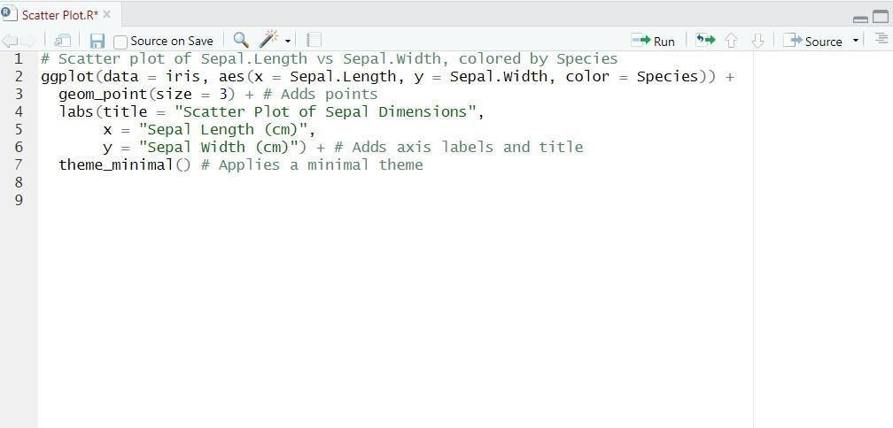

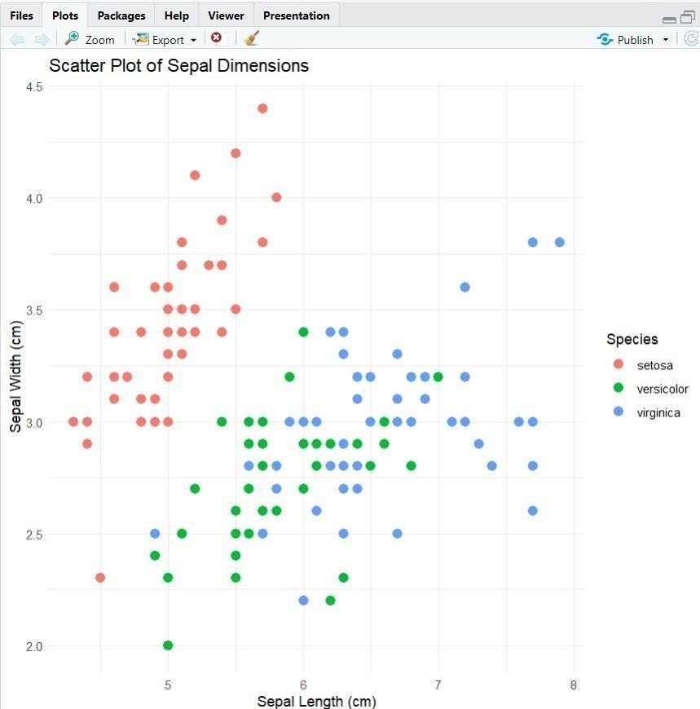

1. **BAR CHART**

# Install ggplot2 (if not already installed) install.packages("ggplot2")

# Load the ggplot2 package library(ggplot2)

# Bar plot of Species counts ggplot(data

= iris, aes(x = Species)) + geom_bar(fill = "steelblue") + # Adds bars filled with steel blue color labs(title = "Count of Different Species in Iris

Dataset", x = "Species", y = "Count") + theme_minimal() **OUTPUT:**

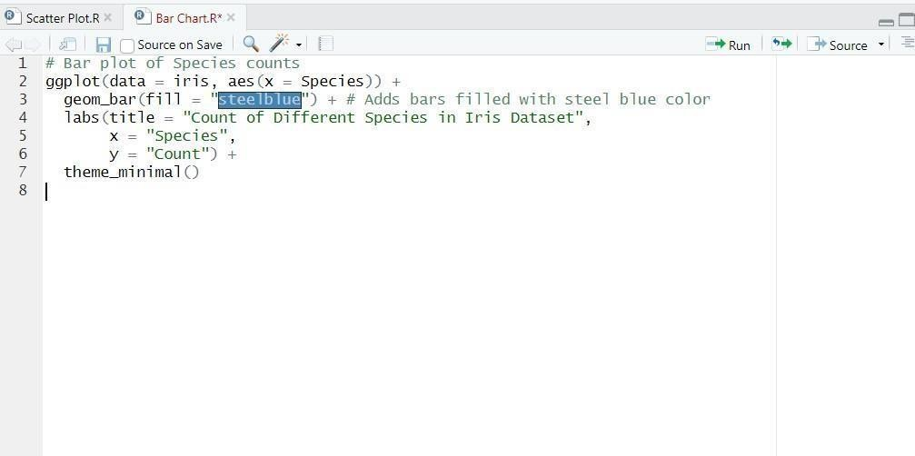

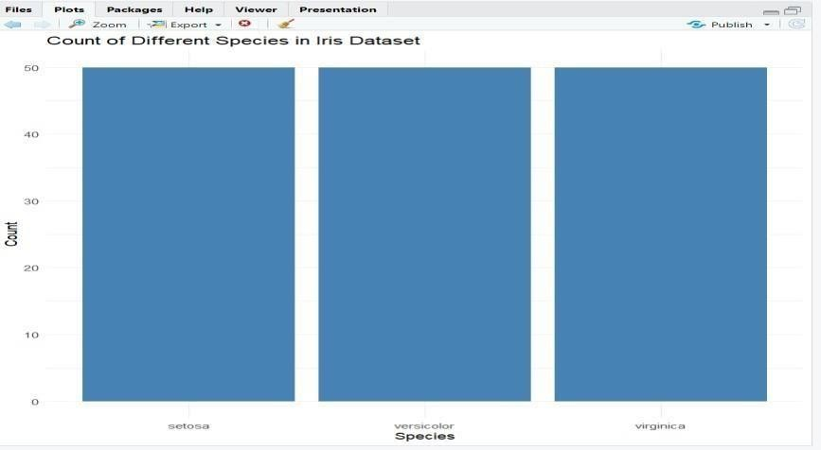

# HISTOGRAM

# Install ggplot2 (if not already installed) install.packages("ggplot2")

# Load the ggplot2 package library(ggplot2)

# Histogram of Sepal Length

ggplot(data = iris, aes(x = Sepal.Length)) +

geom_histogram(binwidth = 0.3, fill = "orange", color = "black") + # Adds histogram bars labs(title = "Histogram of Sepal

Length", x = "Sepal Length (cm)", y

= "Frequency") + theme_minimal()

# OUTPUT:

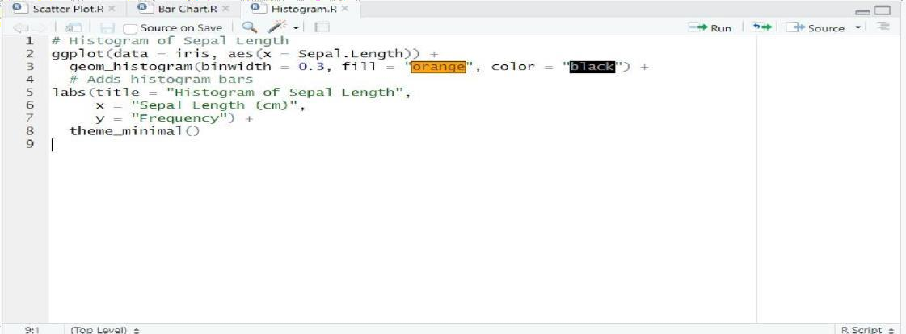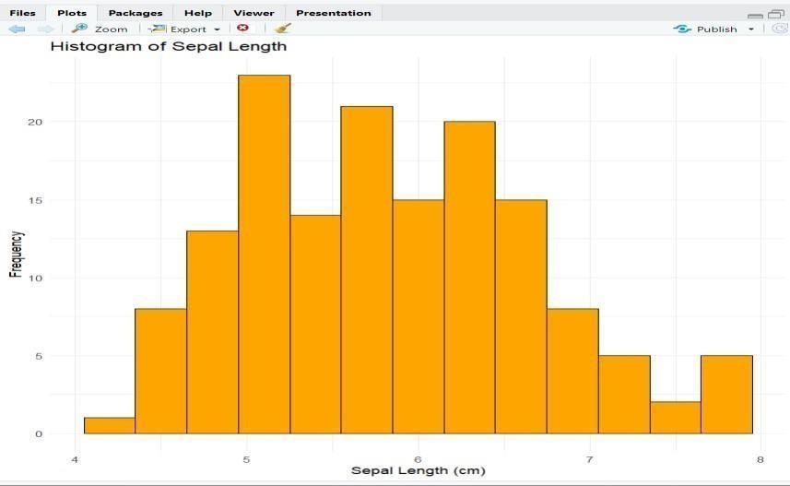

1. **BOX PLOT**

# Install ggplot2 (if not already installed) install.packages("ggplot2")

# Load the ggplot2 package library(ggplot2)

# Box plot of Sepal Length for each Species ggplot(data = iris, aes(x

= Species, y = Sepal.Length, fill = Species))

+ geom_boxplot() + # Adds box plot labs(title = "Box Plot of

Sepal Length by Species", x = "Species", y = "Sepal Length (cm)") + theme_minimal()

# OUTPUT:

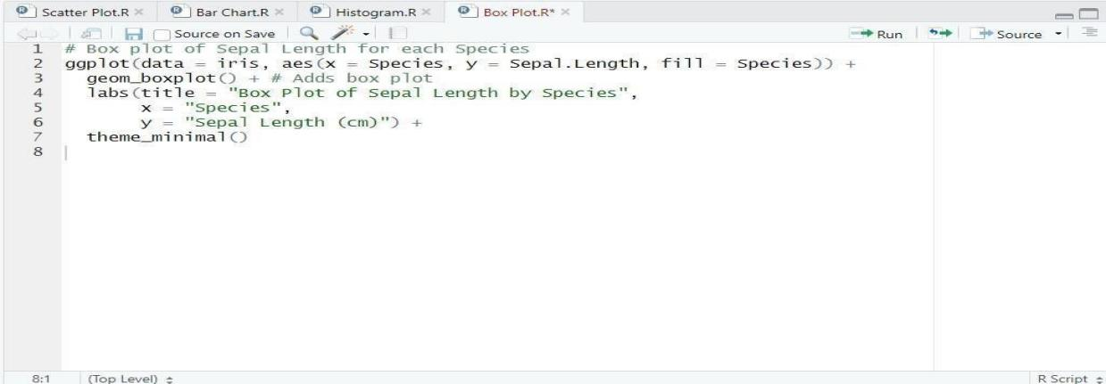

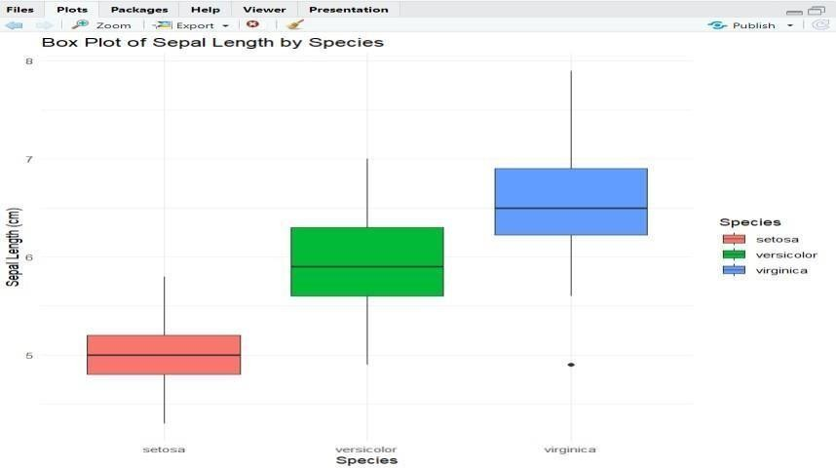

**RESULT:**

Thus, the visualize Data using any plotting framework using R Studio have been successfully executed.